PRISM Training

Accessing Coverage and Reimbursement Information

Table of Contents
Accessing the Coverage and Reimbursement Fee Schedule 2
How to use a downloaded fee schedule 3
Text Filters and Functions 4
Column Descriptions and Field Values for Each Column of the Fee Schedule 6

The information provided by the Coverage and Reimbursement Lookup Tool is intended to provide coverage and reimbursement information for selected procedure codes.

Accessing the Coverage and Reimbursement Fee Schedule

Step 1: The Coverage and Reimbursement homepage can be found through the following link: https://health.utah.gov/stplan/lookup/CoverageLookup.php

On the Coverage and Reimbursement Fee Schedule Download page, providers have the option of downloading fee schedules by the member’s Benefit Plan or provider PAC.

Step 2: Select the member’s Plan Type and/or Provider Type in the dropdown menus, along with the Date of Service to generate a customized fee schedule.

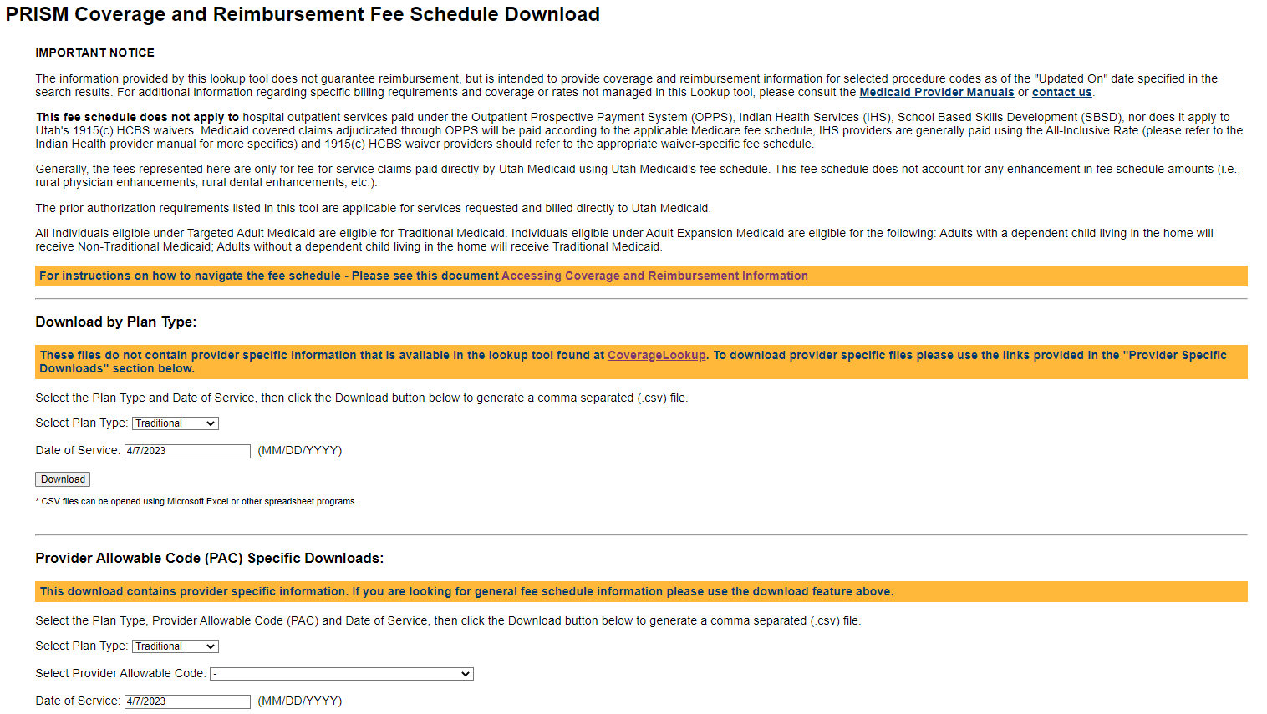
Alternatively, providers may download a comma separated (csv) file containing a list of Procedure codes, Provider Types, and Charge Factors for ALL provider-specific pricing, using the Provider Pricing File ONLY tool.
A HCPCS/NDC Crosswalk can be accessed using the HCPCS/NDC Crosswalk tool. Revenue code coverage information can be generated by using the Revenue Code Download tool.
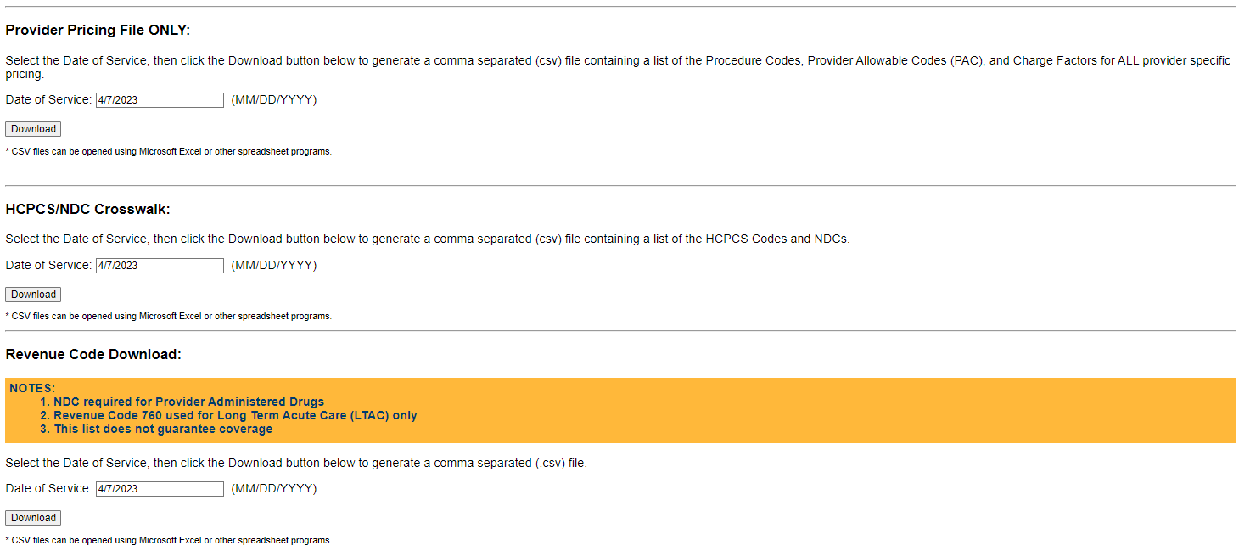

How to use a downloaded fee schedule
There are two primary ways of finding coverage and reimbursement information for procedure codes:
Step 1: To view information for a specific procedure code, search within column A (“ProcCode”) using the Ctrl+F function.

Note: the apostrophe (‘) before each procedure code in column A will not affect search results

Step 2: To view information for one or more procedure codes, simultaneously apply filters to the entire spreadsheet by clicking on any cell in the spreadsheet

Step 3: Navigate to the Data tab and click on the “Filter” button (Data > Filter)
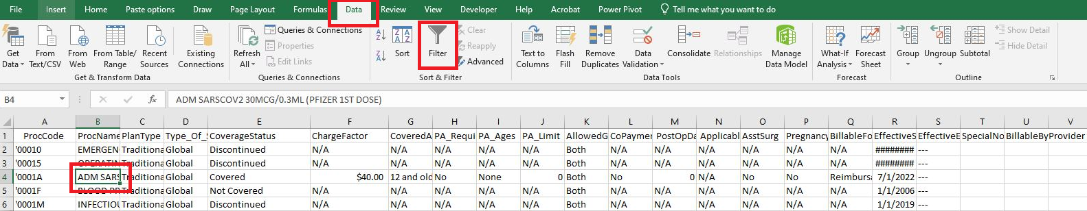

Filters are applied to each column of the spreadsheet, allowing the user to view information that satisfies specific criteria.

Each filter accommodates single or multiple selections.

Step 4: To apply a custom filter, select the drop-down icon for the column of interest, select Text Filters and then select a comparison, like Begins With.

Text Filters and Functions
Text Filters | Function
Equals… | Use to find a specific value
Does Not Equal… | Use to EXCLUDE a specific value
Begins With… | Use to find values that begin with a certain text string
Ends With… | Use to find values that end with a certain text string
Contains… | Use to find values that contain a text string anywhere  in the field
Does Not Equal… | Use to EXCLUDE values that contain a text string  anywhere in the field
Custom Filter | Use to apply any of the above filters, alone or in  tandem

In the example below, we will be applying a filter to select procedure codes that begin with
“000” and ends with the letter “U.”
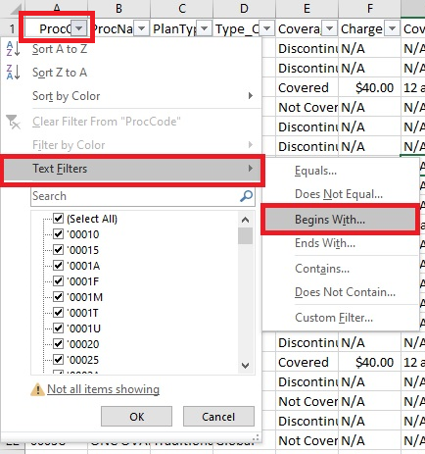

Step 6: Enter the filter criteria and select OK.
In this example, the filtered rows will contain the coverage and reimbursement information for procedure codes that begin with “’000” and ends with the letter “U.”
Please be aware that the apostrophe (‘) in front of the procedure code is required when applying a custom filter to the ProcCd field (column A).
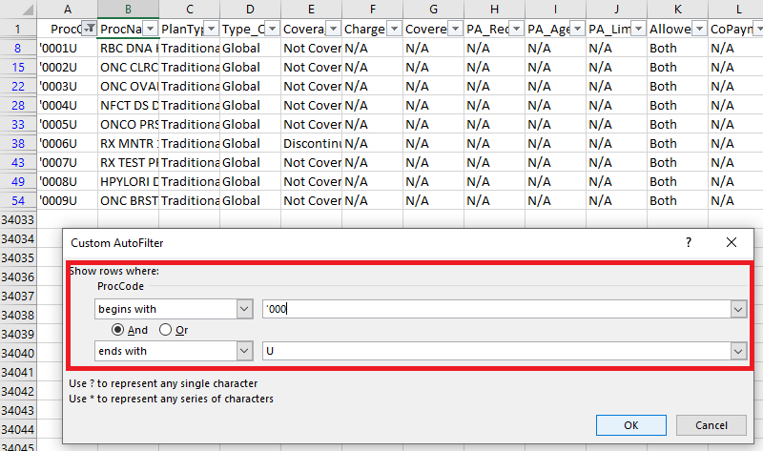

Column Descriptions and Field Values for Each Column of the Fee Schedule

Column | Field Name | Field Values | Field Description
A | ProcCode | Procedure code | Procedure code
B | ProcName | Short description of the procedure code | Short description of the procedure code
C | PlanType | Traditional  Non-Traditional | Indicates the member plan type
D | Type_Of_Service | Anesthesia  Dental  DME – Rental  DME Purchase  Global  Professional  Technical | Indicates the type of service applicable
E | CoverageStatus | Covered  Requires Manual Pricing – Attach Documentation to Claim  Requires Manual Review – Attach Documentation to Claim | Indicates the code coverage status for the member plan type and whether the code requires manual pricing or manual review, and associated documentation
F | ChargeFactor | (Charge factor dollar amount or number of anesthesia base units) | The charge base or fee schedule reimbursement amount
G | CoveredAges | (Covered age range, inclusive) | The age range for which Medicaid covers the service for the member’s plan type
H | PA_Requirements | N/A  No  Quantity limit applies  Required with billed as inpatient  See age range  Unit Limit applies  Yes  Yes, Abortion consent form required  Yes, Hysterectomy consent form required  Yes, Sterilization consent form required  Yes, Wheelchair evaluation forms and PA required | This indicator is used when a prior authorization is required. A valid PA number will need to be submitted on the claim.
I | PA_Ages | None  N/A  Specific age range | Indicates the age range subject to prior authorization requirements
J | PA_Limit | Maximum unit limit allowed | Maximum unit limit allowed by a prior authorization
K | AllowedGender | Both  Female  Male | Indicates whether the service is reimbursable for a specified gender
L | CoPayment | Yes  No | Indicates whether a member copayment applies to the service.
M | PostOpDays | (Number of post operative days) | Only applicable to surgical services reimbursed as part of “global periods” that include the procedure and services provided in the periods immediately before and after the surgical procedure
N | ApplicableDentalArea | (Specific dental area) | Indicates that a dental area designation code must be submitted on the claim
O | AsstSurg | Yes  No | Indicates whether the service is a reimbursable service set forth in the Assistant-at-Surgery Eligible list
P | BillableForNHClient | Covered in per diem rate  Reimbursable for nursing home resident | This Indicator is used to identify whether the service is covered in a nursing home per diem rate or considered an ancillary service for nursing home residents
Q | EffectiveStartdate | (Date on which current fee schedule went into effect) | Date on which current fee schedule went into effect
R | EffectiveEndDate | (Date on which current fee schedule expires) | Date on which current fee schedule expires
S | SpecialNotes | (Additional guidance on coverage and reimbursement policy) | Additional guidance on coverage and reimbursement policy

